

**Employee Management System**

**Design Document**

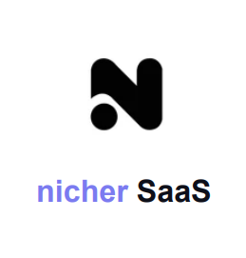

**Apr 20 Report by:**

**SAURAV KAPADIYA (202001033)**

**MALAV ROHIT (202001056)**

**ADITYA JOSHI (202001059)**

**2023**

**Abstract**

The employee management system is a software application that is designed to streamline and automate various HR functions within an organization. This system provides a centralized platform for managing employee data, tracking employee performance, and facilitating communication between managers and employees.

The purpose of this design document is to provide a detailed overview of the architecture, design, and functionality of the employee management system. This document includes information on the system's data model, user interface, security features, and integration with other enterprise systems.

The employee management system is designed to be user-friendly, intuitive, and scalable. It includes features such as employee profiles, time and attendance tracking, performance evaluation, and training management. The system also includes a messaging platform that allows managers and employees to communicate directly within the system.

To ensure data security and privacy, the system includes robust authentication and authorization mechanisms, as well as role-based access controls. It also includes audit trails to track system activity and maintain compliance with relevant regulations.

Overall, the employee management system is designed to improve HR efficiency, increase employee engagement, and support informed decision-making. This design document provides a comprehensive overview of the system's architecture and functionality, as well as the benefits it can provide to organizations of various sizes and industries.

**Table of contents**

1. Class Diagram
2. Sequence Diagram
3. Activity Diagram
4. State Diagram

**1. Class Diagram**

The class diagram for the employee management system is a visual representation of the system's data model, including the various classes and relationships that exist between them. The purpose of this diagram is to provide a clear and concise overview of the system's architecture, allowing developers to understand how different components of the system interact with each other.

The class diagram for the employee management system includes several key classes, including Employee, Manager, Attendance, and Salary. These classes represent the various entities within the system and their attributes and relationships.

The Employee class includes attributes such as name, address, and job title, as well as methods for managing time and attendance and accessing training resources. The Manager class includes similar attributes and methods, as well as additional functionality for managing employee performance and communication.

The class diagram also includes relationships between these classes, such as the association between Employee and Attendance, indicating that an employee is present on which dates. It also includes relationships between Employee and Salary, indicating that employees can update, add salary.

Overall, the class diagram for the employee management system provides a comprehensive overview of the system's data model, allowing developers to understand how the system works and how different components interact with each other.

**Class Diagram for Employee Management System**

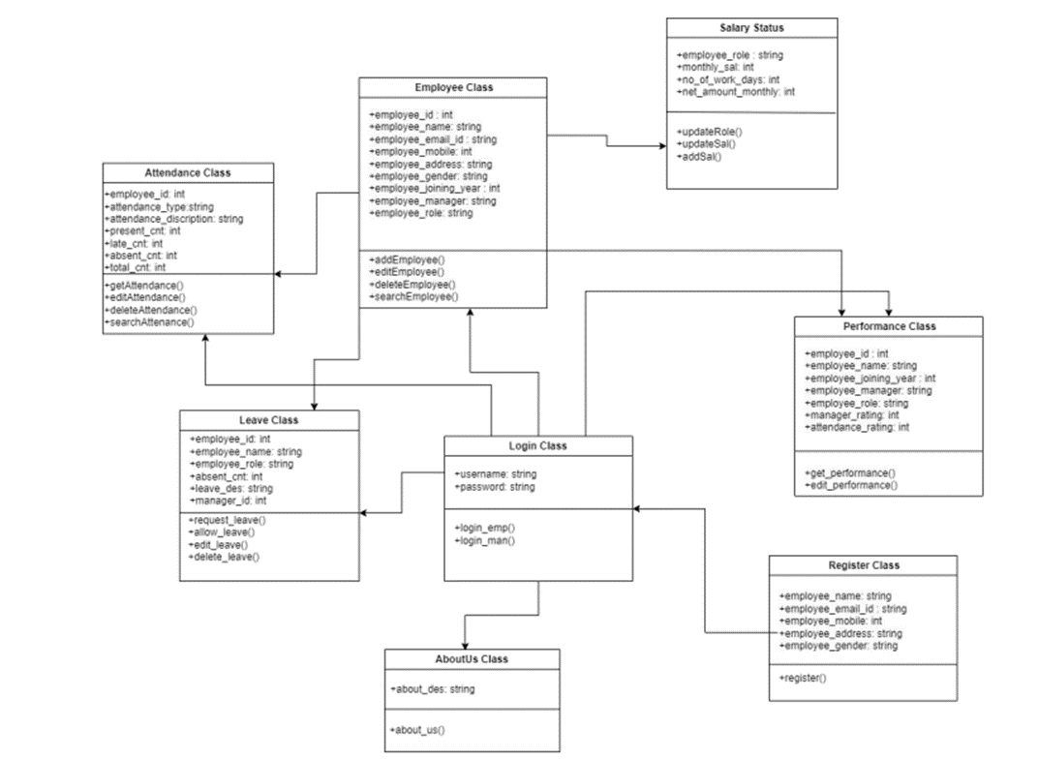

**2. Sequence Diagram**

The sequence diagram for an employee management system outlines the flow of communication and interactions between different components and actors in the system. It typically starts with a user input, such as a request to view or edit employee information, and depicts the steps involved in fulfilling that request.

The diagram may include interactions between the user interface, the database, and various modules or subsystems responsible for handling tasks such as payroll, performance evaluations, and benefits management.

The goal of the sequence diagram is to provide a clear and concise visualization of how the system functions and how different components work together to achieve specific tasks.

**Sequence Diagram for Employee Management System**

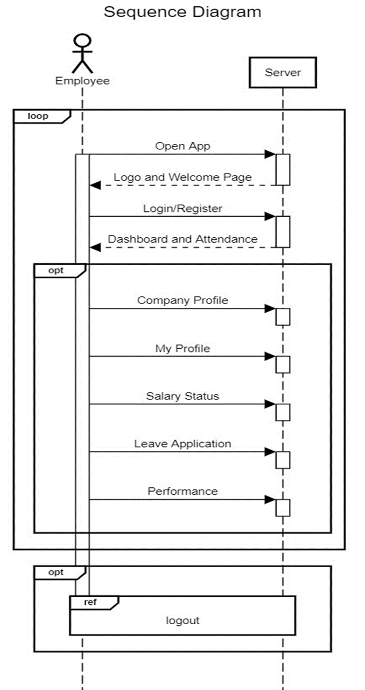

**3. Activity Diagram**

An activity diagram for an employee management system represents the various activities and actions that take place in the system. It illustrates the flow of information and the sequence of tasks performed by different actors in the system.

The diagram typically includes boxes representing actions, arrows indicating the flow of control, and swimlanes representing different roles or departments. The activities depicted in the diagram may include employee onboarding, performance evaluation, salary management, and other HR-related tasks.

By creating an activity diagram, the system designers can analyze and optimize the system's workflow, identifying any bottlenecks or inefficiencies and improving overall system performance.

**4. State Diagram**

A state diagram for an employee management system represents the different states or conditions that an employee or the system can be in, as well as the events that trigger transitions between these states.

The diagram typically includes boxes representing the different states, arrows indicating the transitions between them, and labels indicating the events or actions that cause the transitions. The states depicted in the diagram may include employee onboarding, active employment, leave of absence, and termination, among others.

By creating a state diagram, the system designers can model the behavior of the system, identify potential issues or edge cases, and ensure that the system operates as intended in all possible scenarios.